Welcome to Mrs. Lipsey’s Integrated Math 2 Class
Syllabus
I. My Expectations
That you attain a reasonable understanding and knowledge of the following three topics we will study this quarter:
- Three-Dimensional Shapes – their Surface Area & Volume
- Properties of Triangles
- Properties of Circles

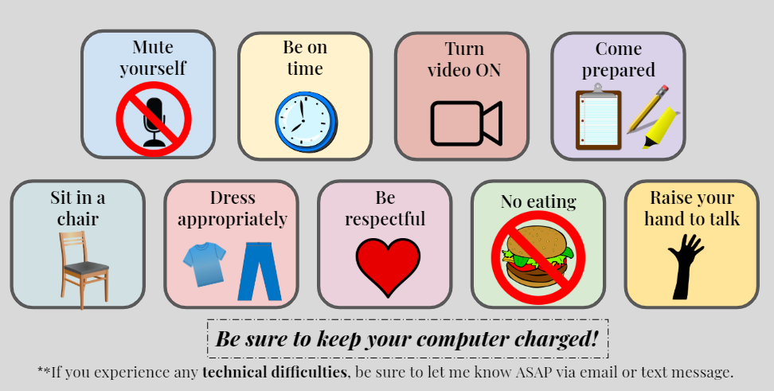
Google Classroom Etiquette:

II. Our Weekly Routine
• Monday – Take notes (take a picture of them & turn them in at the end of the period). – 5 pts
• Tuesday – Complete & turn in a short assignment based on the notes from the previous day. – 5pts
• Wednesday – Take notes (take a picture of them & turn them in at the end of the period). – 5 pts
• Thursday – Complete & turn in a short assignment based on the notes from the previous day. – 5pts
• Friday – Answer any last minute ?’s and take a small quiz (30 minute class) – 10 pts
* Each day students are on Google Classroom LIVE, I give 1 point for being present, 1 point for having the camera ON (without me having to remind them), and 1 point for participating when we do notes (either by asking a question or answering a question I ask during the notes). Points possible in this aspect = 8 pts/week.
III. My Grade Breakdown
• Attendance & Participation (includes being present, having camera ON, and participating) = 20%
• Notes (Classwork) = 20%
• Assignments (Homework) = 20%
• Quizzes (Fridays) & Tests (at the end of each unit) = 40%

IV. Tutoring/Extra Help: Every Monday thru Thursday 12 - 1pm on Google Meet (class code dsi4xsp) or you can click on the link on my webpage. I am always there.

V. My Contact Information Email: janice_lipsey@chino.k12.ca.us
Google Voice/(Text is best!): (909) 334-2575‬ ‬‬‬‬‬

